EXPT NO:3 | CLEANSE DATA BY HANDLING MISSING VALUES, OUTLIERS, AND INCONSISTENCIES USING TABLEAU AND POWERBI
DATE: 10.07.2026

PRE-LAB QUESTIONS (PROVIDE BRIEF ANSWERS TO THE FOLLOWING QUESTIONS)

1. What are the potential impacts of missing values in a dataset, and what are some common strategies to address them in Tableau and Power BI?
Missing values can skew averages, break aggregations, and cause misleading visuals. Common strategies: replacing numeric nulls with mean/median, replacing text nulls with "Unknown," or using calculated fields like IFNULL() (Tableau) or ISBLANK() (Power BI).

2. What is the importance of identifying and addressing outliers in a dataset? How can outliers affect data analysis and model performance?
Outliers can distort averages, correlations, and trend lines, leading to inaccurate insights. In predictive models, they can skew training and reduce accuracy. Identifying them ensures more reliable analysis.

3. What types of data inconsistencies might you encounter during data cleansing, and how can Tableau and Power BI help in resolving them?
Inconsistent text values (e.g., "South" vs. "South Region"), inconsistent date formats, and mismatched units. Tableau's Group/Alias and Power BI's Replace Values/Power Query features help standardize these.

4. How do you identify patterns in data using visualizations to spot missing values, outliers, and inconsistencies?
Using column quality indicators, histograms, scatter plots, and box plots — blank bars indicate nulls, extreme points indicate outliers, and duplicate/split categories in bar charts reveal inconsistencies.

5. What is the role of calculated fields in data cleansing, and how can they be used to handle missing values and outliers in Tableau/Power BI?
Calculated fields allow rule-based, repeatable cleaning — e.g., replacing nulls with defaults or capping extreme values — without manually editing each row, ensuring consistency across the dataset.

IN-LAB EXERCISE:
OBJECTIVE:
To clean a given dataset (e.g., Superstore Sample in Tableau and Financials/Sales Data in Power BI) by identifying and resolving missing values, outliers, and inconsistencies using built-in tools, ensuring the dataset is accurate and ready for analysis.
PROCEDURE:
  - Open the Tool and Connect Dataset o Open Tableau Desktop , Power BI Desktop.
    - Load the built-in dataset (Sample - Superstore in Tableau / Financials in Power BI).
    - Preview the dataset to understand its structure.
  - Initial Inspection o Explore fields such as Sales, Profit, Region, or Product Category.
    - Check for nulls, inconsistent text values (e.g., "South Region" vs. "South"), or date formatting issues.
  - Handling Missing Values o Use Data Interpreter (Tableau) / Power Query (Power BI) to highlight nulls. o Replace missing numerical values with mean/median, and text with "Unknown".
    - Use calculated fields: IFNULL([Field], Default) in Tableau or IF(ISBLANK([Field]), "Unknown", [Field]) in Power BI.
  - Detecting and Managing Outliers o Create scatter or box plots for Sales and Profit to identify extreme values.
    - Choose strategies:
      - Filter them temporarily.
      - Apply caps using calculated columns.
      - Flag them with labels for review.
  - Resolving Inconsistencies o Use Group/Alias (Tableau) / Replace Values (Power BI) to standardize text.
    - Normalize data formats, such as date fields or currency units.
- Validation with Visuals
    - Build dashboards with histograms, bar charts, and box plots to visually confirm improvements.
    - Compare before/after cleaning stages for accuracy.
- Save the Cleaned Dataset o Save as .twbx (Tableau) / .pbix (Power BI).
o Optionally export cleaned data to .csv.
- Summary Dashboard

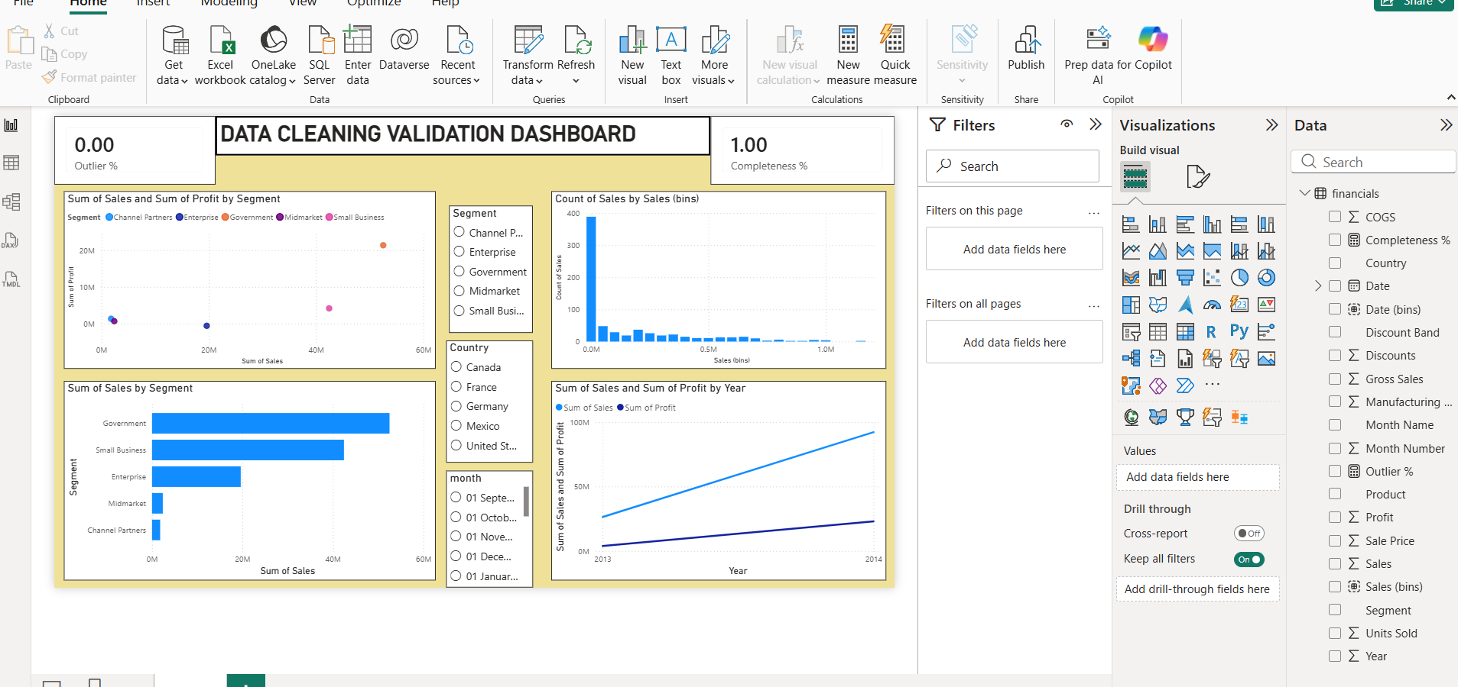

Experiment Dataset:
  - Tableau: Sample - Superstore
  - Power BI: Financials or Sales Data
How to Access:
Tableau:
  - Navigate to: Start Page → Sample Workbooks
  - Or: Help → Sample Data → Open Sample Data Folder
Power BI:
  - Navigate to: Home → Get Data → Excel → Choose sample datasets (e.g., Financial Sample.xlsx)
  - Microsoft also hosts Power BI sample datasets online.
Fields Used:
  - Sales
  - Profit
  - Region
  - Category
  - Order Date / Transaction Date
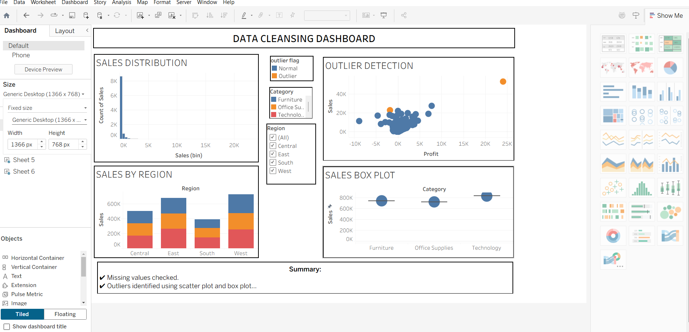

POST-LAB QUESTIONS (PROVIDE BRIEF ANSWERS TO THE FOLLOWING QUESTIONS)
1. What method did you use to replace missing values in numeric fields?
Used a Conditional Column / calculated field with the logic IF(ISBLANK([Sales]), Average, [Sales]) to replace nulls in the Sales field with the column average.
2. How were outliers handled in your dataset and what visual confirmed their correction?
Outliers in Profit were capped using a calculated column (Profit_Capped) that limited extreme high/low values. A scatter plot (Sales vs Profit) and box-and-whisker chart confirmed the outliers before and after correction.
3. What inconsistencies were detected in categorical values and how were they standardized?
Detected inconsistent text in the Segment field (e.g., "Govt" vs "Government" vs "GOVERNMENT"). Standardized using Power BI's Replace Values feature and Trim transformation to remove stray spaces.
4. Describe how calculated fields helped in resolving data issues.
Calculated fields automated the cleaning process — one formula could consistently replace nulls, flag outliers, or cap extreme values across the entire dataset, avoiding manual row-by-row edits.
5. How did your dashboard demonstrate the effectiveness of the data cleaning process?
The dashboard included KPI cards (Record Count, Completeness %, Outlier %), a histogram showing a cleaner Sales distribution, and before/after scatter plots — together visually proving that nulls, outliers, and inconsistencies were resolved

RESULT:

The dataset was successfully cleaned and prepared for accurate analysis using Tableau and Power BI. Issues such as nulls, inconsistencies, and outliers were identified and resolved, improving data quality significantly.

ASSESSMENT

Description |  | Max Marks | Marks Awarded
Pre Lab Exercise |  | 5
In Lab Exercise |  | 10
Post Lab Exercise |  | 5
Viva |  | 10
 | Total | 30
 |  | Faculty Signature

